**[Problem Steps Recorder](http://technet.microsoft.com/en-us/windows/dd320286.aspx)**

Purpose:To introduce a tool, available in windows OS, to record actions which can be used as test evidence instead of attaching step by step snapshots at the time of test execution

Advantages:

1. Small file size
2. Can be viewed using IE browser
3. Saves time in evidence gathering

Disadvantages:

1. Snapshot count needs to be provided
2. Larger file size when snapshot count exceeds 25

Steps to record and save:

1. Open Problem Steps Recorder by clicking the **Start** buttonPicture of the Start button, and then typing **psr**. In the list of results, click on **psr.exe**
2. Click **Start Record**. Start performing your steps as per your test case. You can pause the recording at any time, and then resume it later.
3. Click **Stop Record**.
4. In the **Save As** dialog box, type a name for the file, and then click **Save** (the file is saved with the .zip file name extension). The File needs to be saved on the Home directory (Which is common for all of us) as we don’t have access to save any file with extension .MHTML on our local system.

To view the record of the steps you recorded, open the .zip file you just saved, and then double-click the file. The document will open in your browser.

#### [To adjust settings](http://windows.microsoft.com/en-in/windows7/how-do-i-use-problem-steps-recorder)

When you adjust settings for Problem Steps Recorder, they're only saved for your current session. After you close and reopen Problem Steps Recorder, it will return to the regular settings.

1. Open Problem Steps Recorder by clicking the **Start** buttonPicture of the Start button, and then typing **psr**. In the list of results, click **psr**.
2. Click the help down arrowPicture of help down arrow, and then click **Settings**.
3. You can change the following settings for Problem Steps Recorder:
   * **Output Location.** If you don't want to be prompted to save a file after recording, click the **Browse** button to set a default output file name.
   * Enable screen capture. If you don't want to capture the screen shots along with the click information, select No. This might be a consideration if you are taking screen shots of a program that contains personal information, such as bank statements, and you are sharing the screen shots with someone else.
   * Number of recent screen captures to store. While the default is 25 screens, you can increase or decrease the number of screen shots. Problem Steps Recorder only records the default number of screen shots. For example, if you took 30 screen shots during a recording but only had 25 screen shots as the default, you would be missing the first five screen shots. In this case, you would want to increase the number of default screen shots.

* Once the recording is done the output file will look as shown below.

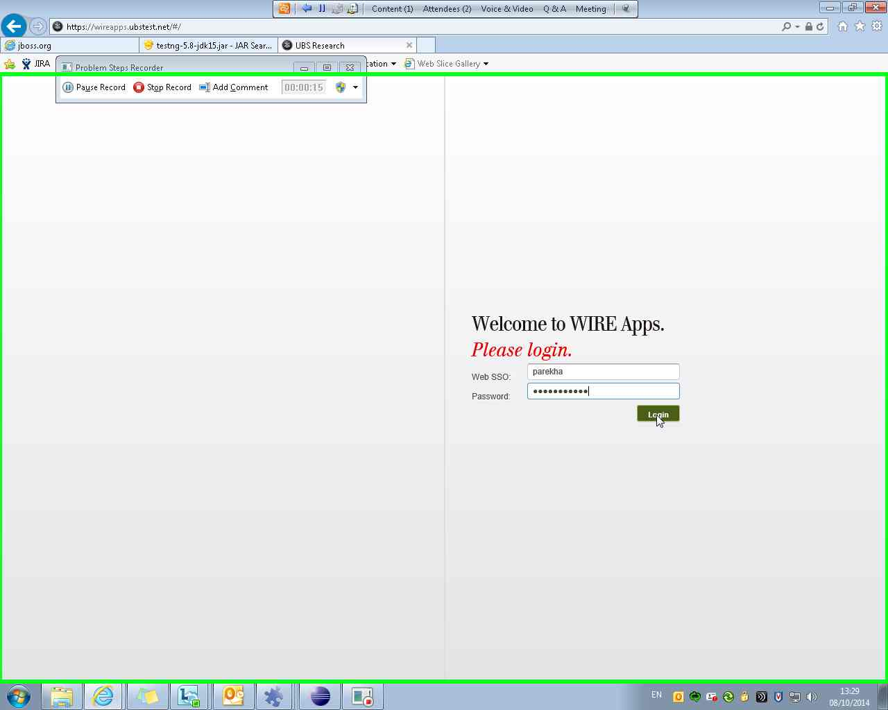

* The Header of each Screenshot will contain the data on what action has been performed by the user. For (e.g.) In the Step 3 user has clicked on the Login button using Internet Explorer.

Problem Step 3: (08/10/2014 13:29:11) User left click on "Login (push button)" in "UBS Research - Internet Explorer"

* Another important thing is to add comment while recording. PSR does not record text which is been provided in the text box. So to make sure there is an option as "Add Comment". To add a comment user should pause the recording and click on Add comment button under PSR. While providing the comment user can also select the section of the web page for which the comment is been applied.

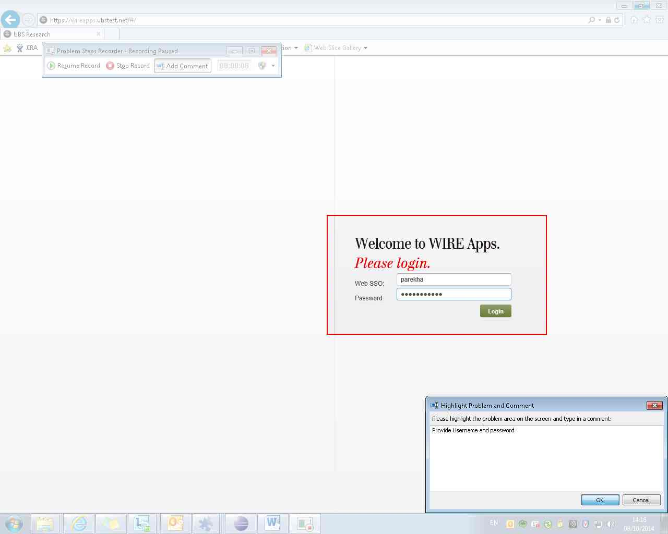

The Header of the step for which comment was applied will look like as below.

Problem Step 3: (08/10/2014 14:16:50) User Comment: "Provide Username and password"

Finally, if any test case have a number of steps and to make sure that for each step a screenshot to be taken, PSR(Problem Steps Recorder) is the best way to use to cover all your steps by click of your mouse.